

Registration Number |  |  |  |  |  |  |  |  | 문제지 번호
Registration Number |  |  |  |  |  |  |  |  | ybm - 05
Name

TOEIC®

Test of English for International Communication




LISTENING TEST

In the Listening test, you will be asked to demonstrate how well you understand spoken English. The entire Listening test will last approximately 45 minutes. There are four parts, and directions are given for each part. You must mark your answers on the separate answer sheet. Do not write your answers in your test book.

PART 1

Directions: For each question in this part, you will hear four statements about a picture in your test book. When you hear the statements, you must select the one statement that best describes what you see in the picture. Then find the number of the question on your answer sheet and mark your answer. The statements will not be printed in your test book and will be spoken only one time.

Sample Answer

Ⓐ Ⓑ  Ⓓ

Example

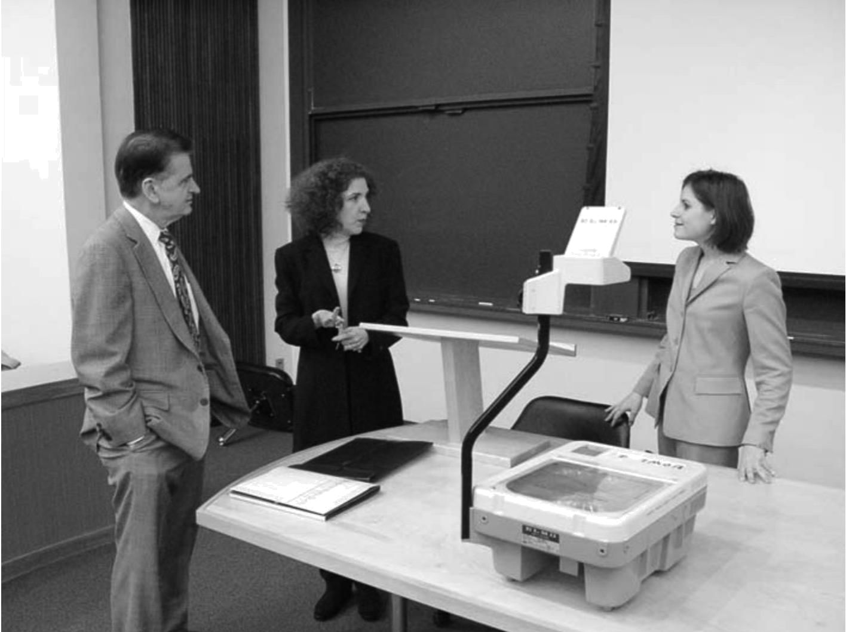

Statement (C), “They’re standing near the table,” is the best description of the picture, so you should select answer (C) and mark it on your answer sheet.

2

1. 1.
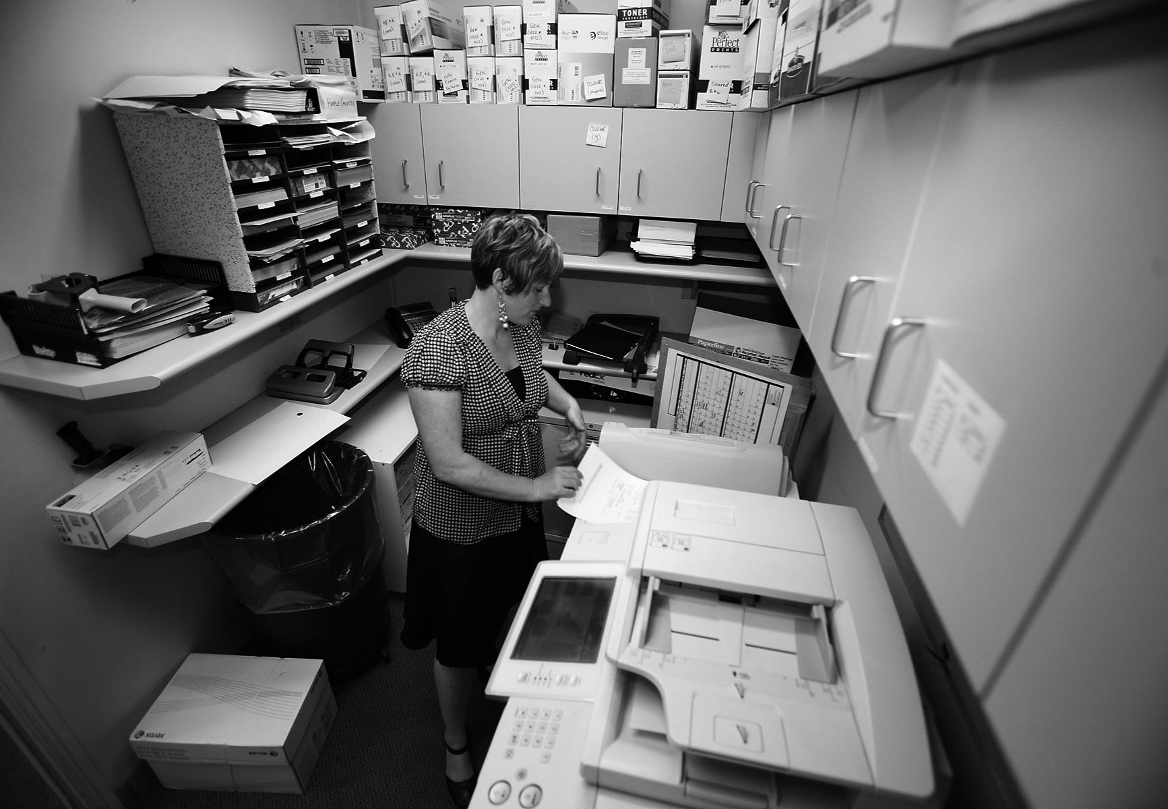

2.



Go on to the next pag

3

3.
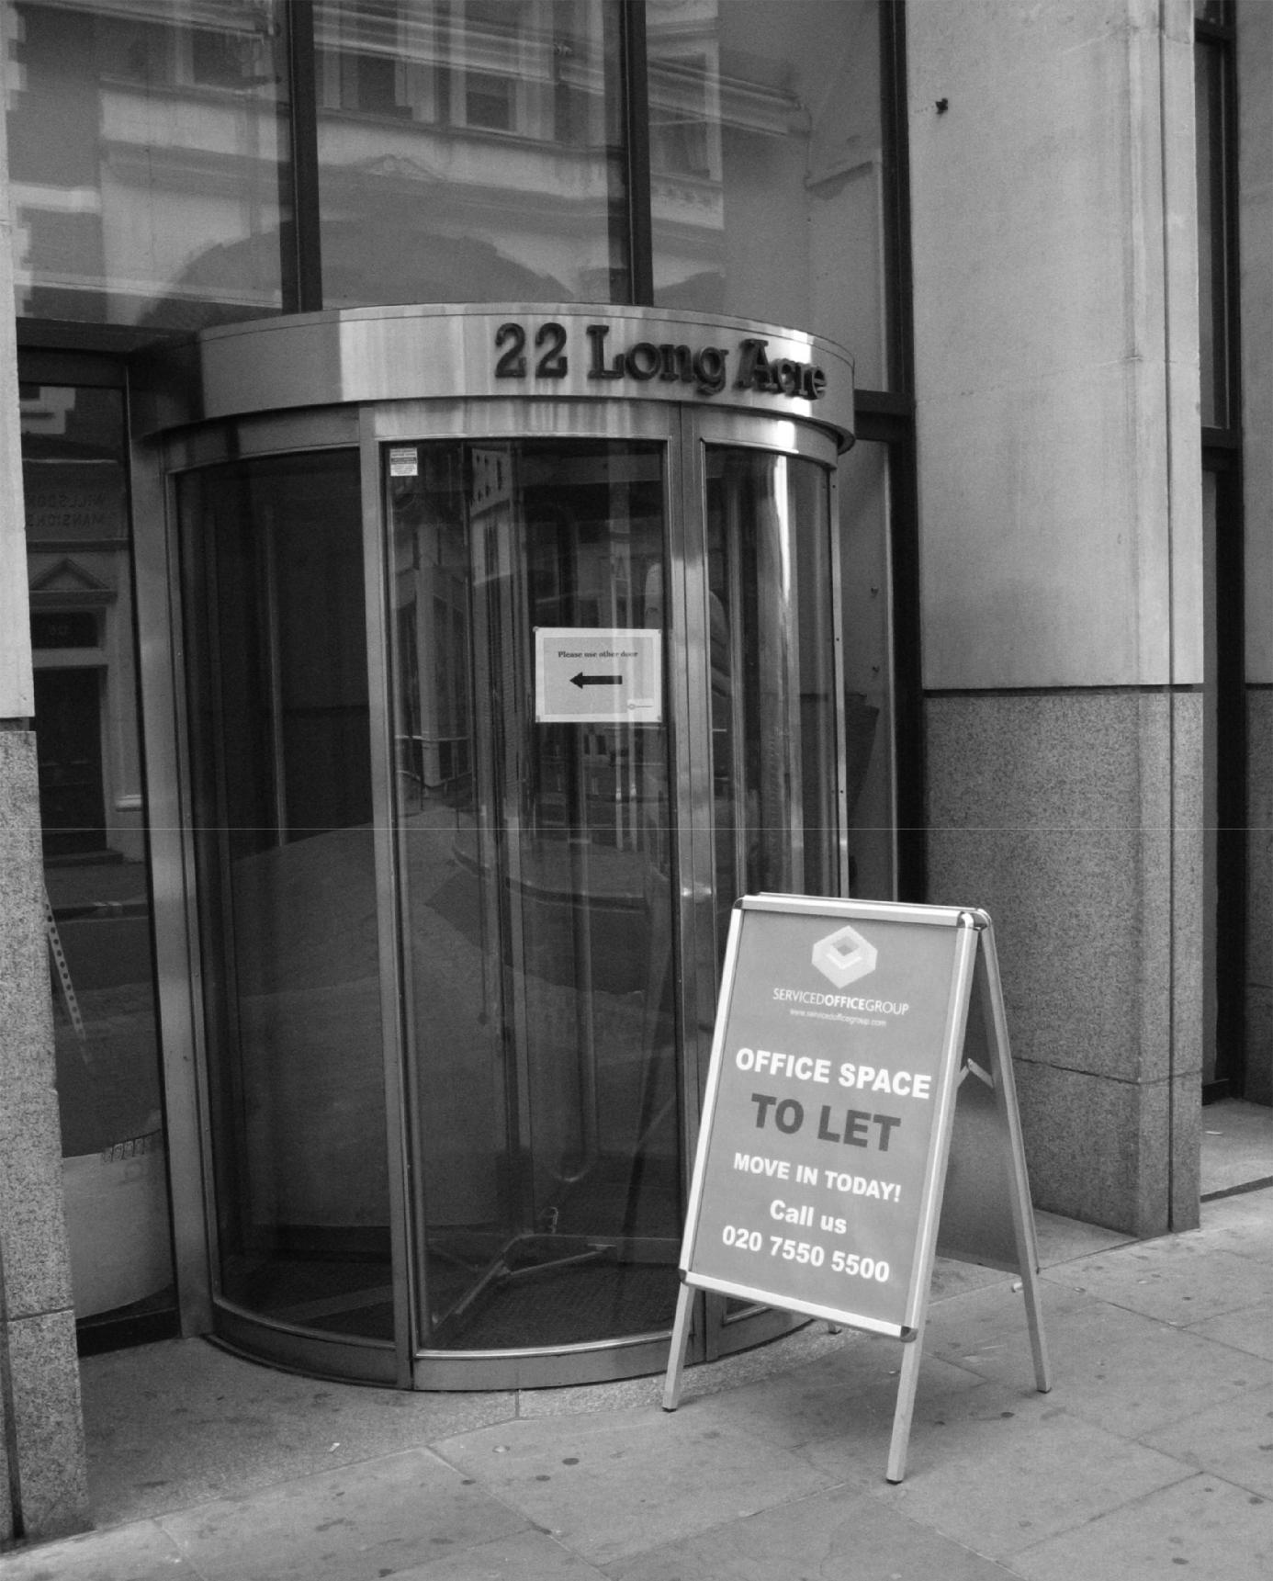

4.
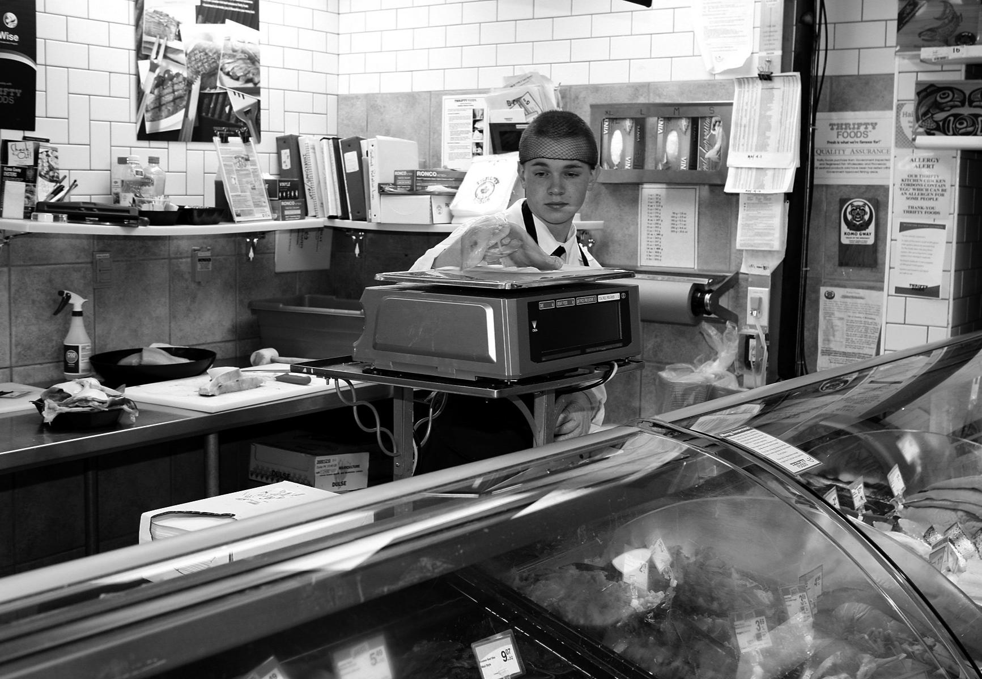

4

5.
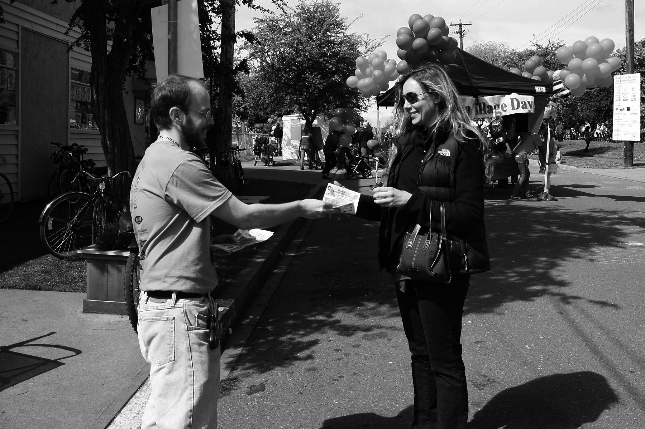

6.
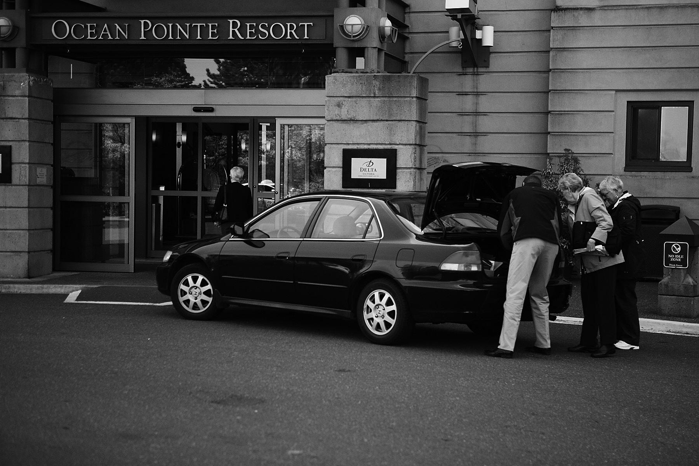

Go on to the next pag

5

7.
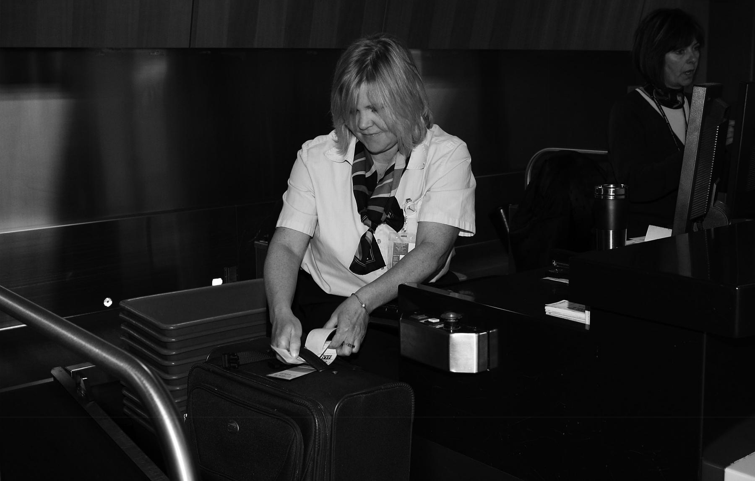

8.
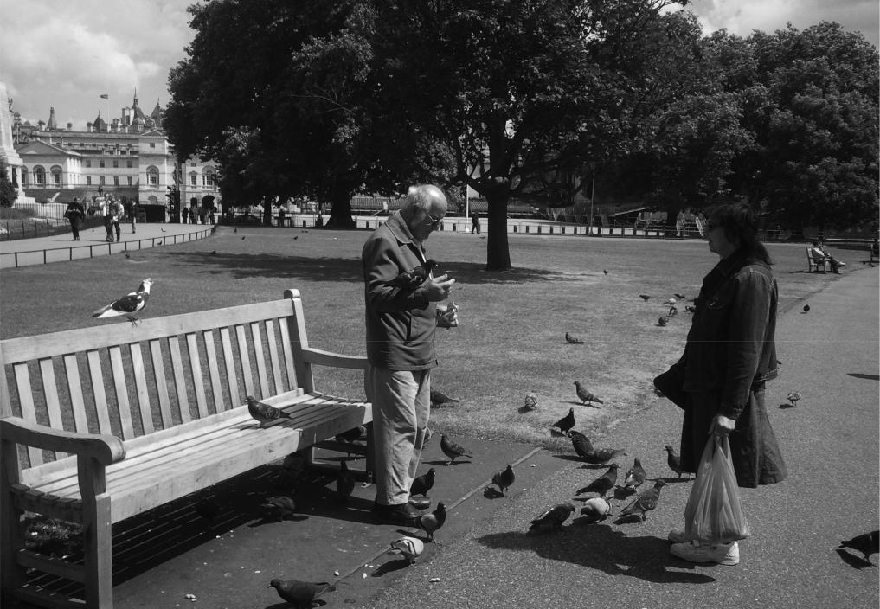

6

9.
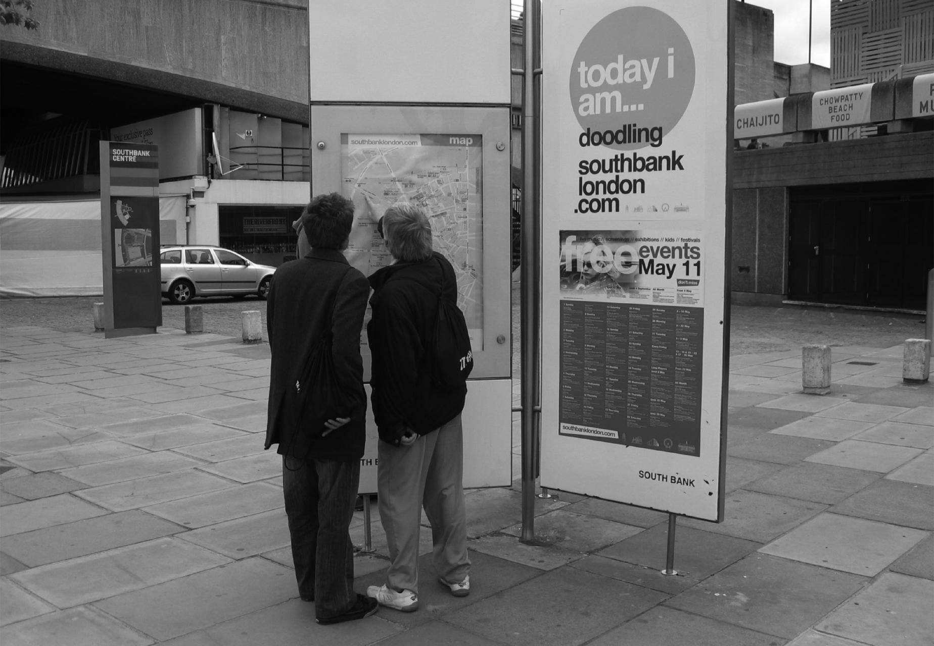

10.
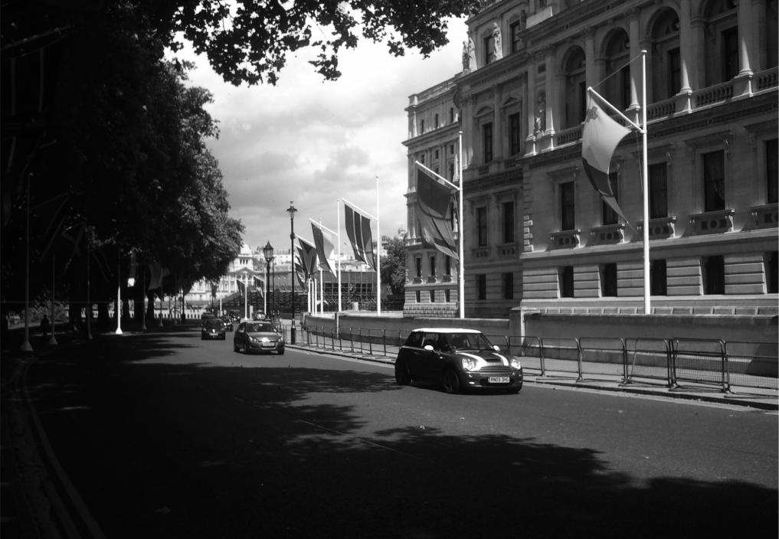

Go on to the next pag

7


Example You will hear:

PART 2
Directions: You will hear a question or statement and three responses spoken in English. They will not be printed in your test book and will be spoken only one time. Select the best response to the question or statement and mark the letter (A), (B), or (C) on your answer
sheet.
Sample Answer
Ⓐ Ⓒ

Where is the meeting room?

You will also hear: (A) To meet the new director.

- It’s the first room on the right.

- Yes, at two o’clock.

The best response to the question “Where is the meeting room?” is choice (B), “It’s the first room on the right,” so (B) is the correct answer. You should mark answer (B) on your answer sheet.

- Mark your answer on your answer sheet.26. Mark your answer on your answer sheet.

- Mark your answer on your answer sheet.27. Mark your answer on your answer sheet.

- Mark your answer on your answer sheet.28. Mark your answer on your answer sheet.

- Mark your answer on your answer sheet.29. Mark your answer on your answer sheet.

- Mark your answer on your answer sheet.30. Mark your answer on your answer sheet.

- Mark your answer on your answer sheet.31. Mark your answer on your answer sheet.

- Mark your answer on your answer sheet.32. Mark your answer on your answer sheet.

- Mark your answer on your answer sheet.33. Mark your answer on your answer sheet.

- Mark your answer on your answer sheet.34. Mark your answer on your answer sheet.

- Mark your answer on your answer sheet.35. Mark your answer on your answer sheet.

- Mark your answer on your answer sheet.36. Mark your answer on your answer sheet.

- Mark your answer on your answer sheet.37. Mark your answer on your answer sheet.

- Mark your answer on your answer sheet.38. Mark your answer on your answer sheet.

- Mark your answer on your answer sheet.39. Mark your answer on your answer sheet.

- Mark your answer on your answer sheet.40. Mark your answer on your answer sheet.

8

PART 3

Directions: You will hear some conversations between two people. You will be asked to answer three questions about what the speakers say in each conversation. Select the best response to each question and mark the letter (A), (B), (C), or (D) on your answer sheet. The conversations will not be printed in your test book and will be spoken only one time.

- What service is the woman asking about?

  - Room cleaning

  - Laundry service

  - Express check-in

  - Conference room rental

- When most likely will the woman give a speech?

  - On Sunday

  - On Monday

  - On Tuesday

  - On Wednesday

- What will the man probably do next?

  - Process the woman’s payment

  - Help the woman with her luggage

  - Take the woman’s jacket

  - Give the woman a bag

- Why does the woman say the meeting should be postponed?

  - Some important data is missing.

  - Some employees will be absent.

  - The computer system has a problem.

  - An executive is scheduled to visit the office.

- When will the meeting most likely be held?

  - Thursday morning

  - Thursday afternoon

  - Friday morning

  - Friday afternoon

- What will the man probably do next?

  - Visit a computer facility

  - Take a lunch break

  - Reserve a meeting room

  - Write an e-mail message

Go on to the next pag

9

- Why is the man traveling to India?

  - To study at a university

  - To sell his company’s products

  - To attend a conference

  - To look for an apartment

- What does the man say about the bag?

  - It is lightweight.

  - It is fashionable.

  - It is too expensive.

  - It is too small.

- What does the woman offer to do?

  - Show the man a different part of the shop
  - Look for other products on a computer
  - Give the man a discount

  - Repair an item for the man

- Why most likely is the woman calling?

  - To change an appointment’s meeting place
  - To remind the man of his appointment

  - To offer the man an appointment

  - To reschedule the man’s appointment

- At what time Friday will the man most likely visit the Stone Complex?

  - 5:00 P.M.

  - 5:30 P.M.

  - 6:00 P.M.

  - 6:30 P.M.

- What does the woman ask the man to do?

  - Bring photo identification

  - Park in an indoor garage

  - Use public transportation

  - Phone her office shortly before arriving

- Why is the woman concerned?

  - She missed a deadline

  - She is giving a presentation.

  - She is starting a new job.

  - She left her home late.

- What is causing the problem?

  - Bad weather conditions

  - A lost passenger

  - Railway construction work

  - Electricity problems in the city

- Where does the man most likely work?

  - At a bank

  - At a real estate office

  - At a publishing firm

  - At an electricity company

- What department does the man most likely work in?

  - Sales

  - Accounting

  - Human Resources

  - Operations

- When will the man probably go to Max’s Supply?

  - On Monday

  - On Tuesday

  - On Wednesday

  - On Friday

- What will the woman probably do next?

  - Phone a delivery person

  - Give the man a catalogue

  - Go to a supply room

  - Make a list

10

- What is the main purpose of the woman’s call?

  - To arrange a demonstration of a product
  - To explain how to use a product

  - To check on a customer’s satisfaction with a product
  - To explain the procedure for returning a product

- According to the conversation, what is special about the DTC-10?

  - Its low price

  - Its technology

  - Its compact size

  - Its speed of operation

- What does the man say will happen next month?

  - He will have a production deadline.

  - He will buy another Ten-Tech product.

  - Clothing will be sent to stores.

  - A new factory will open.

- What does the man indicate about the restaurant?

  - It has a lunch buffet.

  - It is near the speakers’ workplace.

  - It offers delivery service.

  - It has inexpensive menu items.

- What does the man offer to do?

  - Pay for the woman’s meal

  - Postpone a meeting

  - Help the woman prepare a report

  - Design a brochure for the woman

- What does the woman’s colleague say about the restaurant?

  - It is expensive.

  - It is small.

  - The service is slow.

  - It has outdoor seating.

- Who most likely is the man?

  - A factory worker

  - A festival organizer

  - A driving instructor

  - A news reporter

- What kind of company does the woman probably work for?

  - A video game design firm

  - An event planning company

  - A vehicle manufacturer

  - An advertising agency

- When will the Vista be released on the market?

  - In January

  - In February

  - In March

  - In April

- Why is the woman calling the man?

  - To answer his questions about a neighborhood
  - To give details about a vacant apartment
  - To find out his preferences in apartments
  - To postpone a meeting with him

- What does the man say is important to him?

  - Living near public transportation

  - The apartment’s rental price

  - The size of the apartment

  - Living in the downtown area

- What most likely will happen in the afternoon?

  - The woman will meet the man at her office.
  - The man will view an apartment.

  - The woman will send the man a list.

  - The man will sign a rental contract.

Go on to the next pag

11

PART 4

Directions: You will hear some talks given by a single speaker. You will be asked to answer three questions about what the speaker says in each talk. Select the best response to each question and mark the letter (A), (B), (C), or (D) on your answer sheet. The talks will not be printed in your test book and will be spoken only one time.

- Why have the airline’s jets changed appearance?

  - It purchased new planes

  - It changed its slogan.

  - It is celebrating an anniversary.

  - It merged with another airline.

- What will the airline do next month?

  - Begin an online reservations system

  - Expand its hours of its operation

  - Change its name to Globe Airways

  - Open new ticket counters at airports

- Who will receive a discount with the airline this month?

  - New customers

  - Frequent fliers

  - First-class travelers

  - Holders of travel discount cards

- When will the office open again?

  - On Thursday

  - On Friday

  - On Monday

  - On Tuesday

- According to the recording, what does STS provide?

  - A list of local hotels

  - Tour guides for groups

  - Updates on ski conditions

  - Information for volunteers

- What should a caller do to speak to a representative?

  - Record a message

  - Dial a different extension

  - Press number one

  - Stay on the line

12

- What is the audience encouraged to do?

  - Take photos of the performers

  - Make recordings of the performance

  - Applaud while standing

  - Sing during part of the show

- What is available in the lobby?

  - T-shirts

  - Photos

  - Music recordings

  - Video games

- What most likely will happen next?

  - The musical performance will start.

  - Some of the audience will be served a beverage.
  - Tickets for upgraded seats will go on sale
  - The audience will visit the lobby area.

- What happened yesterday?

  - A sports contest was postponed.

  - Some local stores were closed.

  - A flower show took place.

  - Local schools canceled classes.

- What does the speaker recommend that the audience do?

  - Drive more slowly

  - Avoid outdoor exercise

  - Turn down their home heating

  - Visit a nature area

- What most likely will be heard next?

  - Sports news

  - Commercials

  - Medical news

  - Traffic updates

- What is the purpose of the speech?

  - To discuss the health benefits of an exercise
  - To review employee attendance policies
  - To explain a promotional event

  - To welcome new staff

- How long has the speaker worked with the company?

  - For 3 years

  - For 5 years

  - For 10 years

  - For 20 years

- What most likely will the speaker do next?

  - Show a video

  - Distribute brochures

  - Demonstrate an exercise

  - Meet with a customer

- Where most likely is this announcement being given?

  - In a tour bus

  - At a cooking school

  - At a restaurant

  - In a museum

- What is indicated about Longman Folk Village?

  - It is closed for renovations.

  - It is part of a history museum.

  - It includes a farm.

  - It does not allow photography.

- What does the speaker recommend that the audience do?

  - Sit on the right side of the tour bus

  - Carry snacks in their backpacks

  - Unpack their umbrellas

  - Put away their cameras

Go on to the next page

13

- What department does the speaker most likely work in?

  - Training

  - Market research

  - Human resources

  - Customer service

- What is the audience instructed to do?

  - Register for training

  - Go to a computer room

  - Complete some paperwork

  - Collect identification tags

- What most likely will happen in 10 minutes?

  - A meal break will begin.

  - Procedures will be explained.

  - A workshop will conclude.

  - Job interviews will take place.

- Where most likely is the announcement being given?

  - At a software company’s office

  - At a camera store

  - At a convention center

  - At a public park

- Who most likely is Rachel Kim?

  - A magazine writer

  - A software developer

  - A store owner

  - A nature photographer

- What are the listeners asked to do?

  - Visit a Web site

  - Attend a training seminar

  - Test a software program

  - Finish work early for the day

- Where most likely does the speaker work?

  - At a factory

  - At a restaurant

  - At a delivery company

  - At a lighting supply store

- What problem has occurred?

  - Some items were out of stock.

  - The wrong items were delivered.

  - Some items were damaged in shipping.
  - An item was sent to the wrong address.

- What does the speaker ask Ms. Farley to do?

  - Place a new order

  - Confirm a date

  - Visit a warehouse

  - Pay a delivery fee

- Who is John Mason?

  - An auto buyer

  - An auto designer

  - An auto company president

  - An auto industry analyst

- According to the broadcast, who is the Delta aimed at?

  - People who are beginning drivers

  - People with large families

  - People wanting a small car

  - People who drive sports cars

- What is mentioned about the Delta?

  - It is expensive.

  - It has a large engine.

  - It will come in two colors.

  - It will be sold in limited numbers.

This is the end of the Listening test. Turn to Part 5 in your test book.

14



NO TEST MATERIAL ON THIS PAGE

Go on to the next pag

15

READING TEST

In the Reading test, you will read a variety of texts and answer several different types of reading comprehension questions. The entire Reading test will last 75 minutes. There are three parts, and directions are given for each part. You are encouraged to answer as many questions as possible within the time allowed.

You must mark your answers on the separate answer sheet. Do not write your answers in your test book.

PART 5

Directions: A word or phrase is missing in each of the sentences below. Four answer choices are given below each sentence. Select the best answer to complete the sentence. Then mark the letter (A), (B), (C), or (D) on your answer sheet.

- Heavy rain caused the ------- of Taylor City’s third annual outdoor arts and crafts festival.

  - cancel

  - cancels

  - cancelled

  - cancellation

- Our banquet rooms are capable of -------

events of all types and sizes.

  - accommodate

  - accommodated

  - accommodating

  - accommodation

- The monthly rent cost includes heat and hot water, ------- not electricity and cooking gas.

  - or

  - but

  - both

  - unless

- It can often be difficult to ------- real antique furniture from imitation items.

  - merge

  - suppose

  - distinguish

  - expect

- Upon ------- of your résumé, one of our skilled recruiters will review it to determine the most suitable position for you.

  - receive

  - receiver

  - receipt

  - received

- Creating a book of ------- own can be fun and simple with the help of the Writer-Pro desktop publishing program.

  - you

  - your

  - yours

  - yourself

- Riverdale Estates is a luxury condominium community that offers an outstanding ------- of life.

  - position

  - trade

  - quality

  - faculty

- You should become thoroughly -------

with your computer and all of its software programs before you take an on-line class.

  - familiarization

  - familiarize

  - familiarity

  - familiar

16

- The shipment of TK-421 laptops arrived in stores earlier ------- expected.

  - on

  - from

  - than

  - since

- Most warranties on electronic items do not ------- damage caused by improper use of the device.

  - cover

  - decide

  - shade

  - reform

- Call-Tech Plus offers ------- cell phone service at low monthly rates.

  - reliable

  - reliability

  - reliably

  - reliableness

- The car’s trunk is ------- enough to hold luggage for four passengers.

  - included

  - overall

  - insufficient

  - spacious

- The Eagle Room, our largest and most elegant banquet facility, allows groups of up to 200 people to enjoy meals in -------.

  - comfort

  - comforts

  - comforted

  - comfortably

- Telecommuting provides a lot of benefits for ------- the company and the employee.

  - every

  - both

  - either

  - also

- Our summer interns performed all their tasks ------- even though they received only brief training.

  - capable

  - capably

  - capability

  - more capability

- Hanby Developers specializes in the construction of modest yet comfortable townhomes that even first-time homebuyers can -------.

  - afford

  - yield

  - require

  - attempt

- You should not use the Erlian Peak trail

------- you are ready for a long and fairly difficult hike.

  - except

  - rather

  - unless

  - notwithstanding

- Market research reports show that a hotel’s level of ------- is an important factor in determining guests’ overall satisfaction.

  - clean

  - cleanly

  - cleanlier

  - cleanliness

- The Liberty Heights Department Store is now proud to offer gift cards in various

------- from $25 to $300.

  - rates

  - volumes

  - amounts

  - shares

- ------- with a valid driver’s license or state photo ID may use the city’s historical research library.

  - Anyone

  - Other

  - Each

  - Whomever

Go on to the next page

17

- The development of freight containers in specific sizes and shapes helped encourage ------ across the entire shipping industry.

  - standardize

  - standardized

  - more standardized

  - standardization

- The Quick Shot 3 digital camera was recently ------- due to a lack of consumer demand.

  - left

  - responded

  - discontinued

  - merged

- Frequent ------- with clients will help a company better understand the customers’ basic needs and preferences.

  - interact

  - interactive

  - interaction

  - interactively

- Trusty Mortgage Company makes it easy to get a home loan ------- your present financial situation.

  - depending

  - regardless of

  - even if

  - as much as

- Your inquiry will be given ------- attention and you will receive a reply e-mail within one business day.

  - prompt

  - promptly

  - promptness

  - more promptly

- Participants in the science conference will have the chance to take an afternoon

------- to Shockley Research Park.

  - suspension

  - direction

  - excursion

  - renovation

- ------- use our online bill payment system, you must first complete our registration process.

  - Before

  - So that

  - In order to

  - According to

- Laramie Motors recently announced plans to increase ------- of its popular Nida Model 320 sedan.

  - producer

  - produced

  - productive

  - production

- This year’s warm and dry spring weather had a positive ------- on tourism in the entire Tri-County region.

  - reason

  - progress

  - effect

  - conclusion

- Managers of several local shops are reporting stronger sales this quarter

------- the region’s weak economy.

  - even though

  - so far as

  - provided that

  - in spite of

- When ------- the cost of a construction project, you need an accurate estimate of the price of the building materials you will use.

  - calculation

  - calculating

  - calculated

  - calculate

- Team building workshops are designed to ------- cooperation and teamwork among employees.

  - proceed

  - facilitate

  - retrieve

  - approve

18

- All regular staff meetings ------- until Friday afternoon so that team leaders can complete their monthly sales reports.

  - postponed

  - had postponed

  - will be postponed

  - to have been postponed

- Each branch office has a payroll manager who can ------- employees’ concerns about pay and benefits.

  - cooperate

  - address

  - rehearse

  - distract

- The company wants to get a patent for its L38 computerized metal polishing machine, but the management cannot determine ------- the inventor was.

  - wherever

  - what

  - who

  - why

- At Daley Stores, soft music, attractive decorations, and pleasant aromas are coordinated into an environment -------

to enhance the shopping experience.

  - engineered

  - engineers

  - engineer

  - to engineering

- The battery life of your cell phone can

------- by storing the phone in a cool environment.

  - extends

  - extending

  - be extended

  - have extended

- ------- some equipment problems at our Stone Park production facility, shipments of our new Series II mountain bike were delayed.

  - While

  - As far as

  - Given that

  - Owing to

- Skilled presenters always have -------

plans ready in the event of equipment failure.

  - comparative

  - contingency

  - probability

  - establishment

- Sales of the company’s PD-70 tablet computer increased last month, -------

sales of its other handheld devices remained flat.

  - such as

  - not only

  - whereas

  - regardless

Go on to the next page

19

PART 6

Directions: Read the texts that follow. A word or phrase is missing in some of the sentences. Four answer choices are given below each of the sentences. Select the best answer to complete the text. Then mark the letter (A), (B), (C), or (D) on your answer sheet.

Questions 141-143 refer to the following classified advertisement.

Are you ready to earn some extra cash over the holidays?

Paradise Clothing Store wants part-time store clerks needed to help out during our busy holiday shopping season. The positions are perfect for students, parents or anyone else who desires ------- in their work schedule. Come and apply today. We offer paid training, a

- (A) flexible

  - flexibly

  - flexibility

  - more flexible

competitive pay -------, and generous employee discounts. But that’s not all. We offer many

- (A) weight

  - value

  - degree

  - rate

more benefits ------- these, including free uniforms, sales bonuses, and regular pay

- (A) besides

  - except

  - until

  - between

increases. To find out more about the positions, visit our employment Web site at www.paradise.com.

20

Questions 144-146 refer to the following memo.

INTER OFFICE MEMORANDUM

To: All Operations Department staff

From: Daniel Burnham, Managing Director

Subject: Moving Instructions

I have some good news! Work crews will start our long-awaited office renovation project next Tuesday. During the construction, we will move to offices on the 9th floor. After the upgrades are completed, our office will have a ------- layout that will give us all easy access to equipment.

- (A) centrally

  - centralize

  - centralized

  - centralization

We do the move on Monday afternoon, and all employees ------- to use the back exits while 145. (A) requested

(B) requesting

(C) are requested

(D) requests

moving. Later today, you will receive boxes, tape, labels and other ------- for the move.

146. (A) habits

(B) supplies

(C) sources

(D) factors

We will pack on Monday morning, and later today you will get a seating map for the new office. Thank you in advance for your cooperation on this relocation.

Go on to the next pag

21

Questions 147-149 refer to the following announcement.

The Danforth Public Library is having a big book sale!

To make room for its newly ------- books, the Danforth Public Library is having a big one-week

147. (A) acquire

(B) acquired

(C) acquiring

(D) acquisition

book sale. You’ll be able ------- from thousands of quality used books, DVDs, CDs, and

148. (A) choose

(B) choosing

(C) to choose

(D) to have chosen

magazines on sale at amazingly low prices. The sale starts Friday April 11th and -------

149. (A) keeps

(B) passes

(C) streams

(D) runs

through April 18th, and it will take place during regular library hours (8 A.M. to 7 P.M.).

We hope to see you at this great event!

22

Questions 150-152 refer to the following e-mail.

From: Brenda Cosworth (bcos.mail.com)

To: Ned’s Home Supply (homes.mail.com)

Subject: Thank you

Date: March 12

To whom it may concern,

On March 7, I had the chance ------- Ned’s Home Supply for the first time, and I asked for

- (A) visit

  - to visit

  - to be visited

  - have visited

assistance in choosing wallpaper for a living room. I am writing this e-mail to let you know how ------- I was with the service I received. Your sales associate, Jenny Lee, showed me

- (A) pleasing

  - pleasingly

  - pleased

  - please

several types of wallpaper and also gave me ------- advice for decorating my home. These

- (A) disposable

  - winnable

  - valuable

  - avoidable

days, it’s rare to encounter such great customer service, so I feel it should be recognized.

Thank you again for your attentive help.

Sincerely,

Brenda Cosworth

Go on to the next page

23

PART 7

Directions: In this part you will read a selection of texts, such as magazine and newspaper articles, letters, and advertisements. Each text is followed by several questions. Select the best answer for each question and mark the letter (A), (B), (C), or (D) on your answer sheet.

24

Questions 153-154 refer to the following sign.


Tower Park (East Gate)

This is the East Gate entrance of Tower Park, a historic pleasure ground situated in the southern part of the city. The park is linked to the Harbor Island Recreation area by the Taylor Bridge on its far west side. Along the park’s ridges you will find several round hills, including Grayson Hill (100 meters), which offers fine panoramic views of the city. Though not especially tall, it towers above every other hill in the city. The Sawyer, Hamlin, and Pulaski picnic areas, as well as three others, let visitors relax in harmony with nature. Live plays are performed both at the park’s Milton Theater and open-air Youth Theater. Just a few steps from this entrance, you’ll find the Kendall Stadium. As part of a program of improvements to Tower City, the gate’s appearance was recently upgraded by park volunteers. We hope you enjoy this fine pleasure ground.

Park hours (main gate access):

Monday – Saturday 7 A.M. to 9 P.M. (East Gate closes at 8 P.M.)

Sunday 7 A.M. to 7 P.M. (East Gate closes at 6 P.M.)

- What is NOT indicated about Tower Park?

  - It has an outdoor theater.

  - It is in the downtown area.

  - It has several picnic areas.

  - It contains the city’s highest hill.

- What is mentioned about the park’s East Gate?

  - It remains open later than the park’s other gates.
  - It is currently being renovated

  - It is short walk from a stadium.

  - It is connected to a bridge.

Go on to the next pag

25

Questions 155-156 refer to the following advertisement.


We’re Planet Green Inc., and we’re here to help busy professionals with their plants!

Plants do a lot of things for our homes and offices. They make the indoor environment cleaner and purer, and they beautify all types of interiors. They even make your staff happier and more productive employees.

But what happens when you are too busy to care for your plants?

That’s where we can help. Here at Planet Green Inc., our goal is simple: to keep your thirsty plants supplied with water while you or your staff is on vacation.

Our basic $20 service gives you a 20-minute visit by our plant experts.

The service includes: * Watering

* Removal of dry leaves if needed

* Advice about soils/fertilizers

* Guaranteed healthy plants!

Please visit us now at www.planetgreen.ntt or call us at 555-0023 for a no-cost initial consultation.

155. What kind of company most likely is | 156. What is NOT mentioned in the
being advertised? | advertisement?
(A) An interior design company | (A) The address of the company’s Web
(B) A plant watering service |  | site
(C) A garden supply shop | (B) The cost of one of the company’s
(D) An outdoor landscaping business |  | services
 | (C) | How long the company has been
 |  | in business
 | (D) | How to get a free consultation from
 |  | the company

26

Questions 157-158 refer to the following classified advertisement.


FOR RENT – 900 square meters of rarely-available commercial space on the first floor of the Mosley Building – a landmark high-rise with a nearly 100-year history; an open floor plan and large windows make this space ideal for a restaurant or cafe.

GREAT LOCATION – The main entrance to the space is on a very busy part of Wilson Avenue, which has lots of vehicle and foot traffic. There are numerous public parking areas nearby, and the convention center is only a 5-minute walk away.

TRANSPORTATION – Close to the 141, 146, and 7X express buses as well as the Downtown Tourist Loop boarding point.

INCLUDED – Many recent upgrades, including expanded lobby and enhanced public spaces; available high-speed Internet connections; 36-month lease includes reduced rent for the first 6 months; for more information, call Dee Realty at (808) 555-0930.

157. What is indicated about the Mosley 158. What is NOT mentioned about the space

Building? for rent?

(A) It has several elevators. (A) It is on the building’s first floor.

(B) It has a large indoor parking lot. (B) It can be accessed from Wilson

(C) It is in a heavily traveled location. Avenue.

(D) It opened to the public six months (C) It has undergone improvements

ago. recently.

(D) It is located near a central railway

station.

Go on to the next page

27

Questions 159-161 refer to the following e-mail.


E-mail

From: Arturo Santos (SantosFreightInc@mll.com)

To: Ted Munson (Munson@mll.com)

Subject: Your shipping

Date: November 30

Dear Mr. Munson,

I just wanted to follow up on our phone conversation from the 27th, and confirm that I will come to your residence on Saturday, December 12th with shipping boxes and packing materials. Depending on traffic, I expect to arrive at your home at 11 in the morning.

To label your boxes, you will need to do the following:

Mark all boxes clearly and label them as “one of a total.” So, for example, the first of 29 boxes would be 1/29, the second would be 2/29, and so on. You should also mark the destination city and country on top of each box. In your case, you would write “Chicago, USA.” You will also want to write “Fragile” and “Top Load” on the boxes in which you pack your ceramics and other delicate kitchenware. Remember that no loose or unpacked items can be accepted by the receiving warehouse in Chicago.

As we discussed earlier, my crew of movers will meet you at your home at 10 A.M. on January 15th to pick up your items. The delivery time to the warehouse is normally 4 days. Please do feel free to contact me with any further questions you might have.

Regards,

Arturo Santos

159. What is one purpose of the e-mail? | 161. When most likely will Mr. Santos’s
(A) To confirm an appointment | moving crew visit Mr. Munson?
(B) To apologize for shipping damage | (A) | On November 30
(C) To request an extension on a | (B) | On December 12
deadline | (C) | On January 15
(D) To describe the contents of a | (D) | On January 29
shipment

- What can be inferred about Mr. Munson?

  - He is shipping items from Chicago.

  - He is shipping some easily broken items.
  - He used to work for a moving company.
  - He operates a kitchen supply company.

28


Questions 162-164 refer to the following memo.

From the desk of Michael Danvers – Employee Affairs, Eastern Technologies (North Center Branch)

To: All employees

Subject: Staff picnic

Date: May 30th

Hello, all. I just want to update everyone on our staff picnic. It’ll kick off at 10 A.M. on Saturday, June 9th as planned, and it will be free for all staff and their family. On the registration form (RSVP by May 30th), please indicate the number of guests you will bring. We’ll hold it at Pierce Picnic Ground, which has 25 large picnic tables and an outdoor sink with cold running water. There’ll be sports, a concert, and of course great food. In the event of rain, we can take shelter under the tented pavilion there.

There’s been one little change. I’ve just learned that you can drive all the way to the picnic ground via Lemoyne Avenue, which now runs all the way across Calvin Park. Plenty of free parking is available as well. So instead of meeting first and parking at the park’s entrance gate, the plan is now for everyone just to come directly to the picnic area. Directions to the park are available at www.parksonline.com. I hope to see everyone there next Saturday!

Mike

162. What has changed about the picnic? |  | 164. What can be inferred about Eastern
(A) | The starting time | Technologies?
(B) | The meeting location | (A) It has 25 employees.
(C) | The planned events | (B) It holds a staff picnic annually.
(D) | The cost of attending | (C) It lets its staff bring family members to its picnic

163. What is NOT mentioned about Pierce (D) It is headquartered in a downtown

Picnic Ground? area.

- Running water is available there.

- It has two entrances.

- It includes a covered area.

- There is vehicle access to the area.

Go on to the next page

29

Questions 165-167 refer to the following notice.


Notice to guests

We hope you enjoy your stay here at the Emerson Hotel. The hotel consists of two towers, each with 200 suite, deluxe, and standard rooms, and has more than 35,000 square feet of floor space. The following information is for our guests:

- Complimentary parking is available for Gold card holders. For others, covered parking is available for $25 a day on weekdays, and $30 a day on weekends.

- Only the approved number of guests may stay in each room overnight. Rollout beds are available for $20 each night, and additional guests are charged $35 a night in all classes of rooms.

- Noise must be kept to a minimum between the hours of 10 P.M. and 10 A.M.

- An indoor pool, sauna, and exercise room are available for the use of guests only between 9 A.M. and 10 P.M.
- Cooking of any kind is prohibited, except in deluxe and suite rooms that are equipped with kitchen facilities.
- The hotel’s Rosewood Restaurant, located next to the first floor reception desk, is open from 10 A.M. to 11 P.M. every day. Please feel free to take advantage of its complimentary buffet meals from 11 A.M. to 2 P.M. Monday to Friday. Items on its Junior Menu (for kids 12 and under) are half price at all times.

Please note that pets are not allowed on the hotel premises at any time.

165. What is indicated about the hotel? |  | 167. What is NOT mentioned about the
(A) It has separate rooms for pets. |  | Rosewood Restaurant?
(B) | It has a total of 200 rooms. | (A) It is on the building’s first floor.
(C) | It has cooking facilities in some | (B) It has free weekday buffets.
 | rooms. | (C) It closes at 10 P.M. daily.
(D) | It has indoor and outdoor swimming | (D) It offers a children’s menu.
 | pools.
166. How much does the hotel charge for
each extra adult guest?
(A) | $20
(B) | $25
(C) | $30
(D) | $35

30

Questions 168-171 refer to the following memo.


MEMORANDUM

To: All employees

From: Yvonne Nguyen, office manager

Subject: The Clean Earth Program

We actively encourage staff participation in our recycling efforts, “The Clean Earth Program.” Many among our staff have been involved with the program since it started nearly a decade ago, but some newer employees may not be familiar with it. To that end, I’d like to meet with everyone this Friday at 5 P.M. in Staff Room B and show you how the program works. Attendance is mandatory, and it will take about 20 minutes to run through everything.

Before we meet, there are a few things you should know. We’re very lucky in that we could enlist the help of D&S Removal Services for our recycling needs. They have provided us with the big recycling container you see beside the photocopier as well as comprehensive pick-up service. You may place any recyclable items – from folders to cell phones to old printers – into this box for collection. However, we ask that you return used ink cartridges to our office manager, Marge Glowacki, for refilling. If you would like a small container to use by your desk, you can request one by calling David Lembke in custodial services at X-5822.

Through the Clean Earth program, we are striving to recycle at least 70% of our office waste. The program got off the ground when our media room librarian, Douglas Yoon, needed to dispose of 200 of our old seminar videotapes. He contacted a friend of his at D&S Removal Services, and they immediately set up the convenient pick-up program we have now. This means, by the way, that you are welcome to toss your unwanted home videotapes into the big collection box for recycling. We hope everyone will do their part in meeting our recycling goals.

Thank you!

Yvonne Nguyen

Office manager

- What is one purpose of this memo?170. Who most likely started the Clean Earth

(A) To recognize an employee’s service |  | Program?
 | anniversary | (A) | Yvonne Nguyen
(B) To seek volunteers for an upcoming |  | (B) | Marge Glowacki
 | event | (C) | Douglas Yoon
(C) To announce a new recycling |  | (D) | David Lembke
 | program
(D) To give details about a training |  | 171. Which items are NOT collected beside
 | session | the photocopier?
169. The word “enlist” in paragraph 2, line 2 is |  | (A) | folders
 |  | (B) | videotapes
closest in meaning to |  | (B) | videotapes
 |  | (C) | ink cartridges
(A) | secure | (D) | cell phones
(B) | summarize
(C) | assign
(D) | offer

Go on to the next pag

31

Questions 172-175 refer to the following e-mail.


From: Darcy’s Store Customer Service (darcycustserv@mail.com)

To: All Darcy’s Store customers

Subject: Now it’s easier than ever to save money!

Date: June 19

Dear Valued Customers,

Have you checked out Darcy’s online store recently? We’ve just added a great new “Quick Click” feature to our virtual shop. You simply click the image of the item you want to buy, and it instantly appears in your online shopping cart. You can then proceed to our “Quick Checkout” feature and make a purchase using any approved credit card. We have hundreds of items that are available exclusively at our online shop, and you can receive a 20% online discount by entering promotion code C6606 and purchasing a minimum of $50 of merchandise. It’s that easy!

But that’s not all. When you shop online with us, our software keeps track of and stores all the items you’re interested in and automatically makes suggestions based on your preferences. And now our special services, such as express delivery or gift wrapping, can be ordered by simply clicking the appropriate boxes.

We also welcome you to come and visit any of our stores during our regular store hours (9 A.M. – 8 P.M. Mon – Sat, 11 A.M. – 7 P.M. Sun), and check out our big 2-week summer sale that starts in just two days, on Monday the 21st. We’ll be featuring 20% off all lines of clothing sold at all our stores, and we’ll even take up to 75% off select items. We’ll be handing out coupon books for future sales too, so you can keep on saving.

We hope you’ll come visit us for great deals on clothing – online (24 hours), or at one of our great store locations.

We’ll see you soon!

The Management at Darcy’s

32

172. What is the purpose of the e-mail? | 174. What is NOT indicated about the Web
(A) To give details about an | site?
improvement to online ordering | (A) It offers discounts on items not in
(B) To announce the opening of a new | the stores.
store location | (B) It was recently made easier to
(C) To explain a procedure for returning | navigate.
items | (C) It records customers’ preferences.
(D) To promote a store credit card | (D) It features printable coupons.
173. What is required to receive an online | 175. What is mentioned about the summer
discount? | sale?
(A) Buying at least $75 worth of items | (A) It will last for two days.
(B) Entering a promotion code | (B) It will feature discounts on all
(C) Using a store credit card | clothing.
(D) Requesting gift wrapping for an item | (C) It will be held at only one location.
 | (D) It will involve extended store hours.

Go on to the next pag

33

Questions 176-180 refer to the following information on a Web site.


Market Focus Inc. – Be a Product Tester

Home | Community | Join

Test products! Earn money! Influence business and industry!

Becoming a product tester for Market Focus Inc. is a great way to earn money, make your opinions heard, and even pick up insight into the world of market research. Here are the answers to Frequently Asked Questions (FAQs) about product testing.

What kind of company are you, and what do you do?

We are a full-service market research firm that does innovative product tests for a broad range of clients including such award-winning companies as Hanson Foods. The company was founded by market research pioneers David and Beverly Clawson nearly 40 years ago. We were nearly bought out by the large firm DK Research last November, but David and Beverly instead passed Market Focus Inc. down to their sons, Jeff and Daniel. So, for us, market research remains a family affair. We are also a proud member of the National Association of Food Engineers.

I want to be a product tester. What do I do next?

Once you are registered to become a product tester for Market Focus Inc., your name will be placed on an availability list. When you are chosen for market research, you will be notified by phone or e-mail. You will then come to our facility on Logan Street to participate. Depending on the study, you may test food items, toys, cell phones, or even large appliances. To sign up with us, click the “join” link in the upper right and fill out the electronic registration form. The information you provide will go directly to our database, so note that we are not able to accept e-mailed applications.

I’ve been chosen for a product test. How does it work?

First, our recruiter will inform you how much your test pays. You will then be given the survey forms at our first floor reception area, and go to our research room across the hallway. The 200-seat eating area of this modern facility also serves as a working restaurant which is open for lunch daily from 11 A.M. to 3 P.M. Please note that you may not bring your own food and drink into the room, as it is a controlled environment. For the convenience of families, there is a children’s playroom next to the research room. Most of our tests last about an hour.

How often can I participate in product tests?

Names are chosen by a computer at random, based on factors including age and product preferences. You might participate in product tests once or twice in a short time period, and then several months will pass before your next test. Some people get called more than others, but at most you may do the tests 3-4 times a year.

I’m available for a product test. Can I call you and take part in one?

We’re afraid not. Part of market research is having a random group of participants. But please do free to call us to confirm that your contact information is up-to-date.

34

- What is indicated about Market Focus Inc.?

  - It has always been run by the same family.
  - It has won several awards for its service.
  - It recently built a new headquarters building
  - It started its own professional organization.

- How most likely would a person register to be a product tester?

  - By e-mailing the company

  - By visiting a different part of the Web site
  - By visiting the company in person

  - By phoning the company

- The words “pick up” in paragraph 1, line 2 are closest in meaning to

  - spread

  - resume

  - obtain

  - lift

- What is NOT indicated about the research room?

  - It functions daily as a restaurant.

  - There is a children’s play area inside.

  - No outside food is allowed there.

  - It is located on the first floor.

- What can be inferred about the company’s product tests?

  - They mostly involve toys.

  - They all pay the same amount.

  - They are done in groups of three.

  - They cannot be participated in regularly.

Go on to the next page

35

Questions 181-185 refer to the following invoice and e-mail.


TOUR INVOICE

Ace Tours Inc.

Name: Brian Goebel

Tour Name: National Week Short Tour (October 10th to 17th)

Item | Cost (Euro) | Unit | Total (Euro)
Tour cost | €1,200 | 1 | €1,200
Discount (if applicable) * | 10% | 1 | - €120
Single Room Supplement ** | €40 | 6 nights | €240
East Air Flight Surcharge | €140 |  | €140
Visa Fee *** | €50 |  | €50
Insurance | €30 |  | €30
Stated Payment Method |  | (B)
Total |  |  | €1,540

Discounts available: * 15% for groups of 5 or more people traveling together

  - 10% for returning visitors with Ace Tours Inc.

  - 5% for university students (22 and younger)

  - 20% for senior citizens (65 and older)

- For travelers wanting their own hotel room, we offer a single room supplement at cost price of 40 Euro per night

- Visa service is offered at cost price (50 Euros for U.S. citizens, 20 Euros for all others) so we cannot give further discounts on this.

PAYMENT METHODS:

- Pay 50% of the tour cost as a deposit one month prior to departure by bank transfer and the other 50% by another bank transfer before the tour or in cash at our pre-tour meeting.
- Pay the full amount of the tour by bank transfer at least one month prior to the tour.

Our account information can be viewed on Web site’s “payment” page. Please note that we do not accept credit cards, money orders, or checks. When crediting money to our account, please be aware of any transaction fees that may be charged.


From: Brian Goebel

To: Ace Tours Inc. (acetour.mll.com)

Subject: National Week tour

Date: September 1

Greetings, all

I just got my invoice, and I’m looking forward to our tour next month.

I’ve decided, though, that I don’t really need a whole double hotel room to myself for this trip. I’m happy to share a room. Please send me an adjusted invoice, and I will transfer the fees to you, plus 10 Euros to cover the bank charges, this week.

Once again, I will be staying at the Red Wall Hotel in Beijing, so I’ll have no trouble walking to your office for the pre-tour meeting.

See you in October!

Regards,

Brian

36

- Why most likely did Mr. Goebel get a discount?

  - He is a repeat customer with Ace Tours.
  - He is a university student.

  - He is in a group of five travelers.

  - He is more than 65 years old.

- How most likely will Mr. Goebel pay for the tour?

  - By cash

  - By bank transfer

  - By credit card

  - By money order

- What amount does Mr. Goebel want deducted from his invoice?

  - 40 Euros

  - 80 Euros

  - 140 Euros

  - 240 Euros

- The word “cover” in paragraph 2, line 3 of the e-mail is closest in meaning to

  - spread

  - serve as

  - compensate for

  - substitute

- What can be inferred about Mr. Goebel?

  - He has stayed at the Red Wall Hotel before.
  - He is not a citizen of the United States.
  - He will be late for the pre-tour meeting.
  - He will travel without insurance.

Go on to the next page

37

Questions 186-190 refer to the following Web page and user review.


Weekend Audio and Video Exchange

20 W. Fulton Street

Now open four days a week: Thursdays and Fridays 5 – 9 P.M.

Saturdays 10 A.M. – 6 P.M.

Sundays 11 A.M. – 4 P.M.

Internet inquiries and phone orders (all handled personally by the owner):

Monday – Wednesday 10 A.M. – 6 P.M.

Thursdays and Fridays 1 – 9 P.M.

Saturdays and Sundays 10 A.M. – 8 P.M.

www.infoaudio@ml.org 1-800-55-STEREO

About Us

Owned and operated by former sound engineer Brad Nelson for nearly 20 years, Weekend Audio and Video Exchange is a small, friendly store that sells only the finest new and second-hand audio and video equipment. We offer 90-day warranties on all of the used gear we sell, even on items discontinued by the manufacturer. Are you an electronics hobbyist? We often sell vintage non-working stereo equipment at low prices as “projects” simply because we cannot stand to throw the items out. We also sell dust cloths, cleaning fluid, and much more. Each day we’re open, we put out a different showcase item on our front display counter – DVD players on Thursdays, new stereos on Fridays, used stereos on Saturdays, and flat-screen TVs on Sundays.

So come in and look around – you’re sure to find something you like.

Want to help us and help our environment? During this week’s (March 15–18) store hours, we are giving away some of our old but still usable display cabinets. Please call us if you are interested in a free, gently used cabinet for your home.


Reviews Unlimited

User name: Michael Sanders Date posted: 3/22 (Thurs.)

You should buy your stereo at Weekend Audio and Video Exchange. When I went there, they had a beautifully-restored used stereo system on display as their “showcase item.” It wasn’t cheap, but it sounded terrific. They do offer some lower-priced equipment, and the owner, Brad Nelson, really knows electronics. But, for me, the best thing about this store is the ambience. I came with two fellow members of my jazz band, and we all had a great time browsing around. It’s like being in an electronics museum. The store is open only 17 hours a week, but Mr. Nelson is always busy repairing equipment in his free time. I highly recommend this place!

38

- What is NOT sold in the store?

  - Cleaning supplies

  - Shop display cabinets

  - Equipment that does not work

  - Equipment that is no longer made

- When most likely could Mr. Nelson only be reached online?

  - Wednesday at 7 P.M.

  - Thursday at 4 P.M.

  - Friday at 8 P.M.

  - Saturday at 11 A.M.

- On what day did Mr. Sanders most likely visit the store?

  - On Thursday

  - On Friday

  - On Saturday

  - On Sunday

- What did Mr. Sanders say he liked most about the store?

  - The atmosphere

  - The prices on merchandise

  - The knowledgeable sales staff

  - The availability of repair service

- What is indicated about Mr. Nelson?

  - He is a colleague of Mr. Sanders.

  - He used to be a sound engineer.

  - He works about 17 hours a week.

  - He is a member of a music group.

Go on to the next pag

39

Questions 191-195 refer to the following schedule and e-mail.


TC-110 model cell phone - product demonstration schedule

Date: July 19(Sat.)

Shopping Center: Milford Mall, Cotter Avenue and Market Street

Locations: Booth A - East End (in front of Top Electronics)

Booth B - West End (beside Electronics Plus)

09:00 A.M. ‒ 10:00 A.M. Set up booths (Sam Phillips, Frank Kolodziej)

10:00 A.M. ‒ 12:00 P.M. Demonstrations (booth A ‒ Lisa Kim; booth B – Barry Sims)

12 P.M. ‒ 2:00 P.M. Lunch break (food available at the mall’s Central Food Court)

2:00 P.M. ‒ 4:00 P.M. Demonstrations (booth A ‒ Don Park; booth B – Amy Everett)

4:00 P.M. ‒ 6:00 P.M. Demonstrations (booth A ‒ Mary Sato; booth B – Don Park)

6:00 P.M. ‒ 8:00 P.M. Demonstrations (booth A ‒ Amy Everett; booth B – Dale Hill)

8:00 P.M. ‒ 8:45 P.M. Close down and clean up (1–2 flex staff)

Things to note: Lisa and Don have switched times so that Don may have a straight afternoon shift; snacks and beverages will be given out to visitors at both booths from 2 P.M. to 4 P.M.; the mall closes at 9 P.M. sharp, so the management wants us to finish our clean-up no later than 8:45.
Remember! Our sales target is $4,000 per booth. Suggest that each shopper buy a cover and extra batteries to go with their new TC-110 phone. Good luck.


From: Lucy Lopez (llopez@mll.com)

To: Andy Mullins (andymul@mll.com)

Subject: Sales event

Date: July 15

Hi Andy,

I just wanted to let you know that I got approval from Tom Calero, our floor manager, to fill in for Mary Sato on Saturday. Evidently, she has to stay home all weekend so that her plumber can come and do some urgent repairs. Since you organized the sales event, I had one favor to ask. I’m familiar with the specifications of our TC-110 from our Web site and promotions, but I have not handled the phone itself. If it’s OK, could I pick one up from the R&D department? I’d love to test it before showing it to shoppers.

Thanks in advance for your help with this.

Regards,

Lucy Lopez

40

- What is NOT indicated about the sales event?

  - It has specific sales goals.

  - Phone accessories will be on sale.

  - Food will be served in the afternoon.

  - It will take place over two days.

- What can be inferred about Milford Mall?

  - It is located next to an outdoor market.
  - It is extending its hours for the sales event.
  - It recently got new management.

  - It has more than one electronics store.

- When most likely will Ms. Lopez do product demonstrations?

  - From 10 A.M. to 12 P.M.

  - From 2 P.M. to 4 P.M.

  - From 4 P.M. to 6 P.M.

  - From 6 P.M. to 8 P.M.

- What is indicated about Ms. Sato?

  - She is currently a manager.

  - She has a weekend service appointment.
  - She is working in place of Mr. Park.

  - She organized the sales event.

- What did Ms. Lopez request?

  - A coupon

  - A brochure

  - A mobile phone

  - A Web site address

Go on to the next pag

41

Questions 196-200 refer to the following e-mails.


From: Henry Kamal (hkamal@hmail.com)

To: Simon Bonner (sbonner@hmail.com)

Subject: Trip

Date: April 22

Greetings Simon!

Well, it’s only been a month since I moved up to this Operations Manager position, and I already have a big trip ahead of me. Next week I will be touring production facilities in Dagastan, but, as you know, I’ve never been there. I copied and pasted my itinerary right here: ----------------------------------------------------------------------------------------------------------------------

Itinerary for Mr. Henry Kamal (four sites to be visited in Dagastan)

Sun May 2 Arrive Dagastan, meet guide (Anatoly Kopec), stay overnight at Deluxe Class Kalovov Hotel (near Convention Center)

Mon May 3 – Fri May 7 production facility site visits
Site |  | Transit point / accommodation |  |  | Transportation
Vostog |  |  | Khasang / Zhongda Hotel |  |  | Charter flight
Antonov |  |  | Parmaty / Regent Hotel |  |  | Charter flight
Darig |  |  | Slovensko / Tambova Hotel |  |  | Charter flight
Mokbata |  |  | Lubnyan / Silver Hotel |  |  | Charter flight*

*depart Dagastan International Airport at 05:15 Fri May 7 ----------------------------------------------------------------------------------------------------------------------

What do you think? Is this itinerary too hectic? I know you’ve visited the facilities in Dagastan before, so I was hoping you could field a few more questions. First, what is the food like? And how is the accommodation there? Also, I’m wondering if I can buy things with local currency there, or if I need to use dollars and Euros. Any help you can give on these matters would be most appreciated.

Best regards,

Henry


From: Simon Bonner (sbonner@hmail.com)

To: Henry Kamal (hkamal@hmail.com)

Subject: Site visits

Attachment: Dagastan “sampler” (May 8-13)

Hi, Henry

Belated congratulations on your new position. I’m sure you will be happy with it. Interestingly enough, I followed almost the same itinerary on my facility tour in Dagastan last May (see my attached “sampler” of random trip pictures) except that I stayed in Slovensko before flying to Parmaty. The itinerary does move you around quickly, but it never seems rushed. Evenings, in particular, are relaxed.

All of the accommodation on the trip is Deluxe Class, except for the Standard Class Tambova Hotel. You’ll have breakfast there before your site visit, and the service can be slow, so you may want to wake up early that day. Some of the meals in Dagastan are better than others, but overall the food is reasonably satisfying.

I’m afraid, however, I don’t know whether or not visitors can use the local money in Dagastan, or what other kinds of money are accepted. The rules have probably changed since they established the Free Enterprise Zone (FEZ) last August. If it’s up and running, the Dagastan visitor’s Web site may have a list of currencies that are in use.

I hope this helps some. Please do feel free to ask me more questions as they arise.

Take care,

Simon

42

- What is inferred about Mr. Kamal?199. On what topic does Mr. Bonner say he

(A) He will travel with two guides in | has no knowledge?
Dagastan. | (A) The quality of Dagastan’s
(B) He recently received a promotion. | accommodation
(C) He used to travel with Mr. Bonner. | (B) The pace of an itinerary
(D) He will attend a convention in | (C) Food offered during an itinerary
Dagastan. | (D) Dagastan’s currency regulations

- The word ‘field’ in paragraph 2, line 2 of200. What does Mr. Bonner include with his

the first e-mail is closest in meaning to |  | e-mail?
(A) | deny | (A) | A travel itinerary
(B) | answer | (B) A link to a Web site
(C) | spread | (C) | Some travel photos
(D) | commence | (D) | Menus from Dagastan

- Which site visit most likely involves a stay at a Standard Class hotel?

  - Vostog

  - Antonov

  - Darig

  - Mokbata

Stop! This is the end of the test. If you finish before time is called, you may go

back to Parts 5, 6, and 7 and check your work.

43

NO TEST MATERIAL ON THIS PAGE

